
FIN2010 Financial Management
Lecture 2: What is a Firm?




Review — What is Finance?




Investors who have money


Financial Industry

Lecture 4: What is a Firm

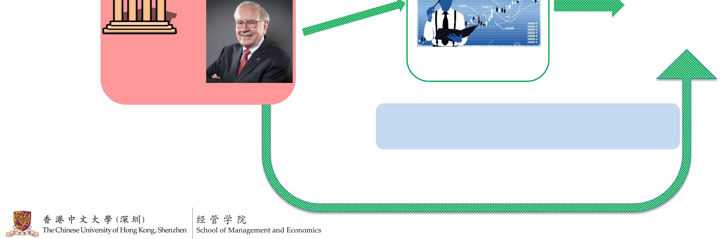




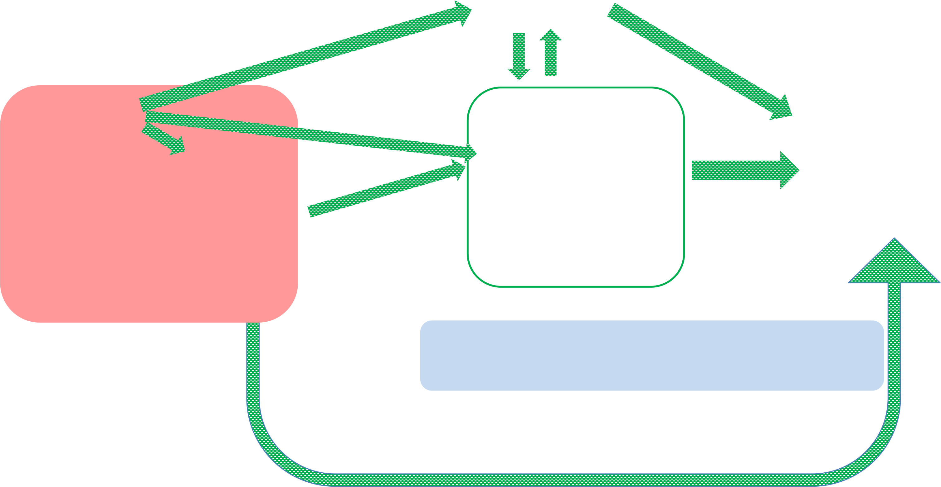
Review — Financial Institutions
Commercial Banks
Individuals
Borrowers
Institutions | Financial Market

Money Managers
Buy Side  (Have money) | Sell Side (Offer service)

Exchanges (e.g. Shenzhen Stock Exchange)
Investment banks (CICC (中金), Goldman Sachs) Brokerage firms (e.g. CMSC (招商证券))
Data vendors (e.g. Wind, Bloomberg)

Lecture 4: What is a Firm 3


Agenda
•Organizational Forms of a Firm
–Sole proprietorship
–Partnership
–Limited liability company (LLC)
–Corporation
•Organization Structure of a Corporation
•Agency Problems
 | Lecture 4: What is a Firm | 4

Forms of Business Organization
•Sole proprietorship, partnership, LLC, and corporation•They differ in many aspects:
– | • | Initial capital required for registration
– | • | Legal entity (法人) or not
– | • | Limited liability (有限责任) or unlimited liability (无限责任)
– | • | Tax
– | • | The control rights (控制权)
– | • | Transferring ownership
– | • | Raising capital
– | • | …
•As an investor, you need to understand what deal you are getting into!
 | Lecture 4: What is a Firm | 5

Sole Proprietorship | 个体户
Cuihua Wang starts a pancake booth.

Sole proprietorship: the simplest form of business. Only one owner.
- | The business and the owner are the same entity. |  | 6
 |  | Lecture 4: What is a Firm | 6




Sole Proprietorship
• | What is good about sole proprietorship? |  |  |  | 7
– | Easy to start: 0 requirement for initial capital; little paperwork. |  |  |  | 7
– | Only pay personal income tax. |  |  | Still need to register your business | 7
– | Full control over the business. |  |  |  | 7
• | What are some potential problems? |  |  |  | 7
– | Unlimited liability: if a customer gets sick and sues you, you are solely responsible, and there is no upper limit on how much you need to compensate. |  |  |  | 7
– | Limited resource (capital, human resource, etc.). |  |  |  | 7
• |  | In China, sole proprietorship can hire up to 7 employees. |  |  | 7
 |  |  | Lecture 4: What is a Firm |  | 7

Partnership | 合伙企业
Cuihua Wang meets Fugui Li. Now they sell pancakes and baozi.

Partnership = sole proprietorship with 2+ owners
 | Lecture 4: What is a Firm | 8

Partnership
• | What is good about partnership? |  |  | 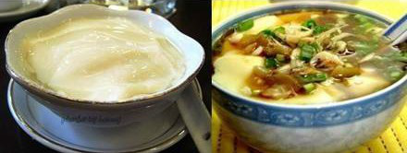 | 9
– | More resource (capital, human resource). |  |  |  | 9
– | Only need to pay personal income tax |  |  |  | 9
• | What are some potential problems? |  |  |  | 9
– | Unlimited liability |  |  |  | 9
– | Fight over control rights |  |  |  | 9
• |  | Example: Cuihua wants to sell sweet tofu; Fugui wants to sell salty tofu. |  |  | 9
– | Hard to raise capital |  |  | 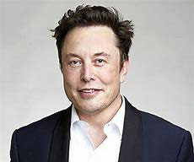 | 9
• |  | Example: Elon Musk is not going to invest,  because if he invests $100,000, he may lose millions if customers get sick. |  |  | 9
due to unlimited liability |  |  |  |  | 9
 |  |  | Lecture 4: What is a Firm |  | 9

Limited Partnership (LP) |  | 有限合伙企业
 | Elon Musk loves their Baozi and wants to invest. They form a limited partnership and now opens a restaurant.
In LP, there are two types of partners:
•General partner (GP) : at least one who bears unlimited liability and runs the business
•Limited partners (LP): other partners who bear limited liability and usually do not run the business
•Makes it easier to raise capital from investors!
•Under limited liability, you only lose what you’ve invested in the worst case scenario
•The typical form used by money managers (such as venture capital and private equity)
 | Lecture 4: What is a Firm | 10

Corporation  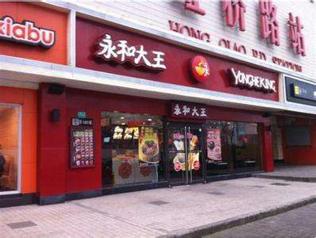 | 股份有限公司  Their restaurant is so successful, and they start opening chains. Now they need  additional capital, so they registered a  corporation for their business.
•Corporation: a formal legal entity (法人), separate and distinct from its owners.
 | Lecture 4: What is a Firm | 11

Key Features of Corporations
– | Biggest advantage: very easy to raise capital Limited liability for all investors. |  |  | 12
– | Easy to transfer ownership |  |  | 12
• |  | Corporation: does not need other owners to agree |  | 12
• |  | All other forms: majority must agree |  | 12
– | Downsides:  High initial capital: private ￥10M, public ￥50M |  |  | 12
– | Pays double tax |  |  | 12
• | Corporate tax: China: 25%; US: 21% after Trump (1stterm), 35% before Trump |  |  | 12
• | Owners get taxed again when receiving salary or payouts |  |  | 12
• | Other Features |  |  | 12
– | Separation of ownership and management (discussed later today) |  |  | 12
 |  |  | Lecture 4: What is a Firm | 12

Corporation—Private and Public
•Can be private or public
•Private: a firm held under private ownership.
•Public: stocks are traded in the exchanges. Public firms are subject to stricter regulations and disclosure rules.
Private firms |  | Public firms |  |  | 13
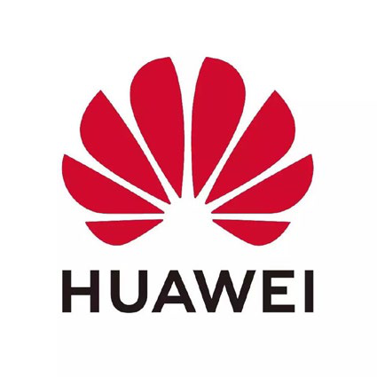 | 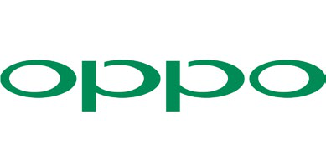 |  | 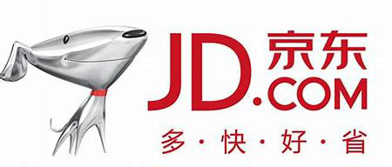 | 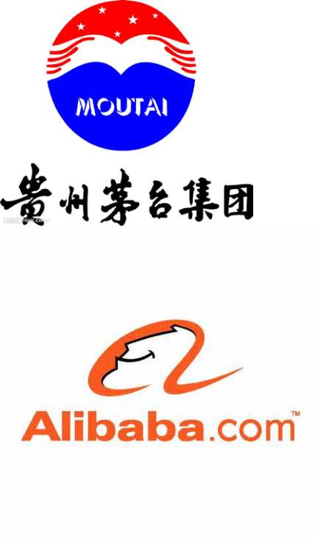 | 13
 | 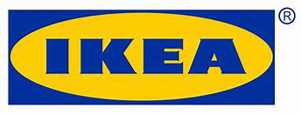 |  | 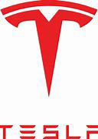 |  | 13

 |  | Lecture 4: What is a Firm |  |  | 13

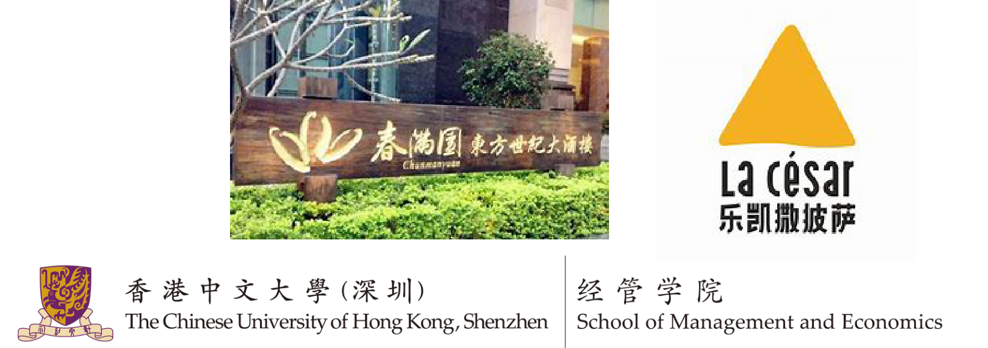
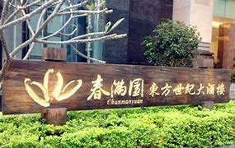
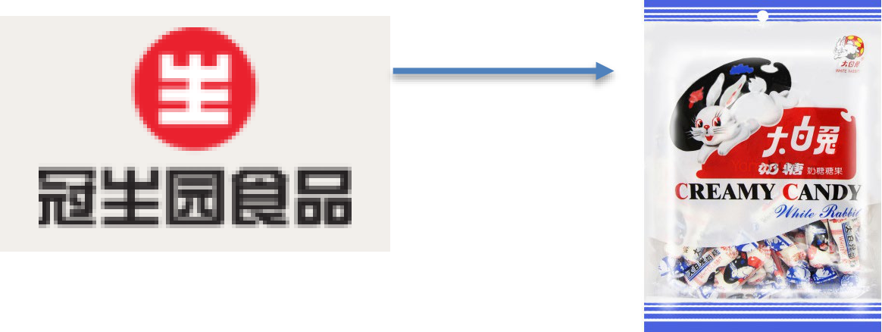

Limited Liability Company (LLC)

有限责任公司

•A hybrid form of business organizations that combines features of both a corporation
and a partnership. Good ‘middle ground’: safer than a partnership,
–Legal entity Corporate but simpler and cheaper than a corporation.
•Limited liability Corporate
•Double taxed in China Corporate
•Individual taxes in some countries such as U.S.
–Require relatively little capital to start (￥500k in China) Partnership
–Possible to transfer ownership, but difficult (need majority to agree) Partnership
•Suited for small and medium sized firms (China: 2-50 owners)
– | Example: restaurant chains, manufacturing firms | Produces

Lecture 4: What is a Firm 14

Comparison
 |  | Limited Liability | Tax | Management | Transfer  Ownership | Raising  Capitals
  Initial
  Capital (RMB)
 | 0 | No | Individual income tax | Full control | N/A | Difficult
  Sole Proprietorship
 | 0 | No | Individual income tax | Shared by owners | Difficult | Difficult
  Partnership
 | 0 | Mixed | Individual income tax | Shared by owners | Difficult | Relatively easy
  LP
 | 500,000 | Yes | Double taxes | Shared by owners | Difficult | Relatively easy
  LLC
 | Private:10M Public: 50M | Yes | Double taxes | Separation of management and ownership | Easy | Easiest
  Corporation

Lecture 4: What is a Firm

The Most Suitable Business Form?
To meet the needs of the business, you can start at any point. sole proprietorship →partnership →LP →LLC →Corporation Note: not all business has to follow the path of
•Ms. Lai and her daughter plan to sell fruits in front of CUHK (SZ) •Didi Chuxing Technology Co.
•A small group of programmers with limited capital, providing consulting and coding service
 | Lecture 4: What is a Firm | 16

Agenda
•Organizational Forms of a Firm
–Sole proprietorship
–Partnership
–Limited liability company (LLC)
–Corporation
•Organization Structure of a Corporation
•Agency Problems
 | Lecture 4: What is a Firm | 17

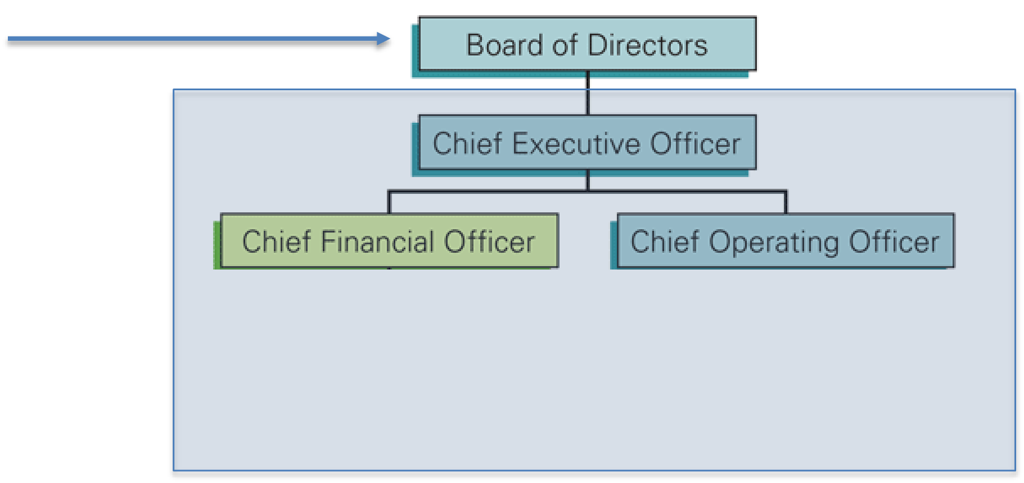
Corporations: Ownership and Management are Separated

Investors

Vote
Selects
Firm

-  -  - | Investors vote to form a board that represents the investors. The board chooses a CEO and other top executives.  The CEO manages the firm.
Investors cannot directly decide how a firm runs!
 | Lecture 4: What is a Firm | 18

Ownership structure of JD.com, Inc. (JD)
Owners Managers  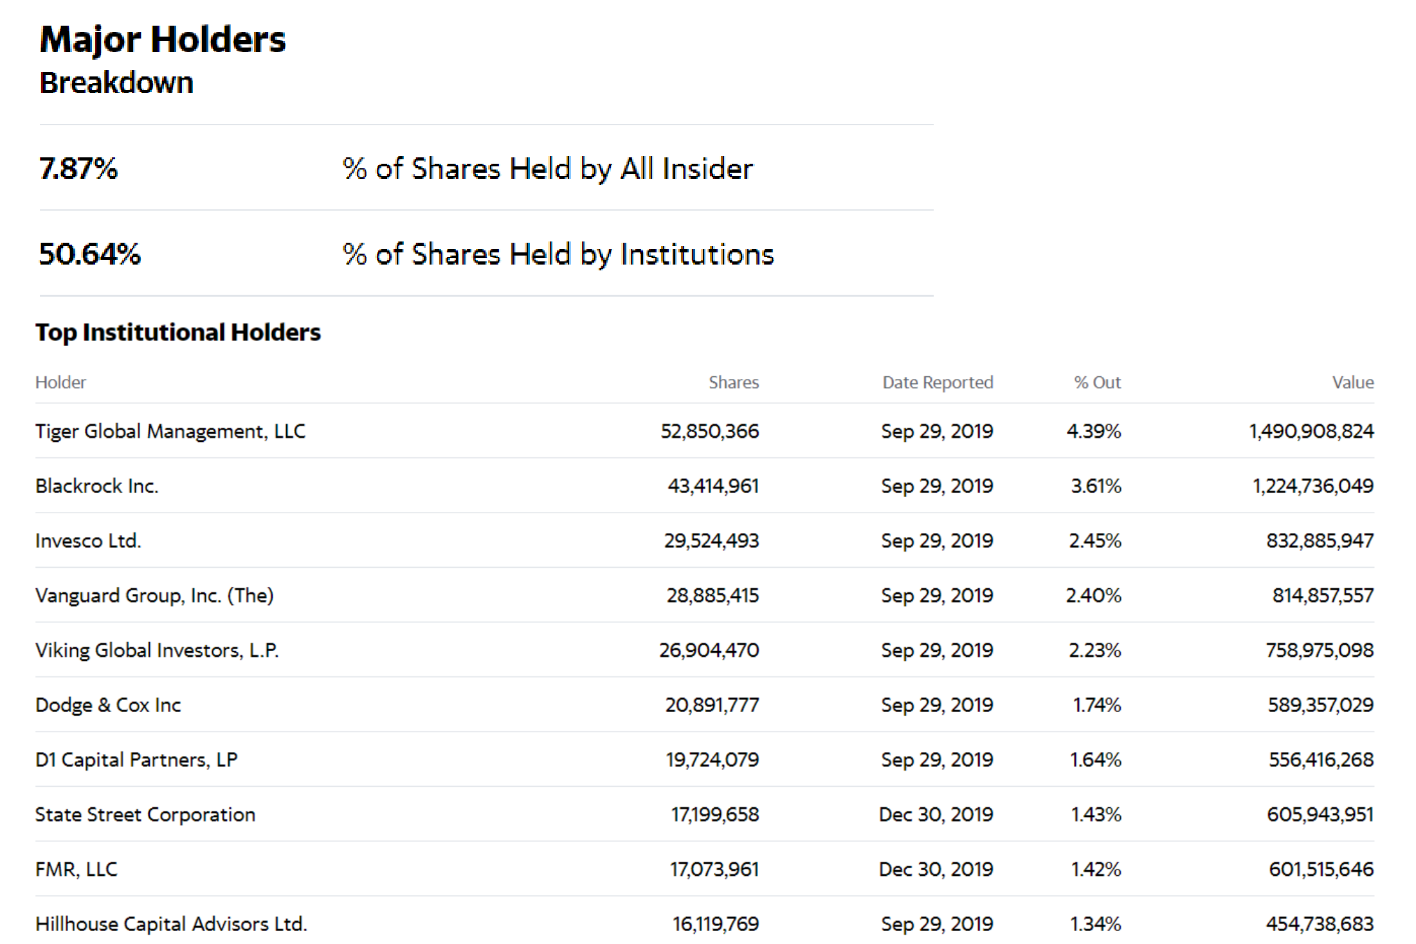  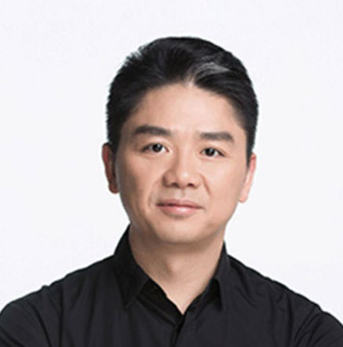 |  | 19
 | Lecture 4: What is a Firm | 19

Financial Management Goals
•What do investors want?
–  – | Maximize return.  Which means they want the management team to maximize firm value.
•What should be the CEO’s goal?
–Primary goal: maximize stock price or shareholders’ wealth
•How should the CEO achieve the goal?
– | Increase revenue |  | 20
• | Gain market share |  | 20
• | Expand to new markets |  | 20
– | Minimize cost |  | 20
• | Internal: manage workers more efficiently |  | 20
• | External: negotiate better deals from suppliers |  | 20
 |  | Lecture 4: What is a Firm | 20

Financial Management Goals and CSR
•Starting from 1950s, and especially after 2000, people are rethinking whether the goal should be only to maximize shareholders’ value.
–
•It becomes a problem when firm value increase →some stakeholders (especially the weak) suffers. –
•CSR (Corporate Social Responsibility): firms should operate ethically and contribute positively to the society while pursuing economics objectives.
– | Essentially, there should be a boundary on things that the manager can do when trying to maximize the firm value. |  | 21
– | Laws may not be able to cover every aspect. |  | 21
 |  | Lecture 4: What is a Firm | 21

Example: Bad Behaviors will be Punished
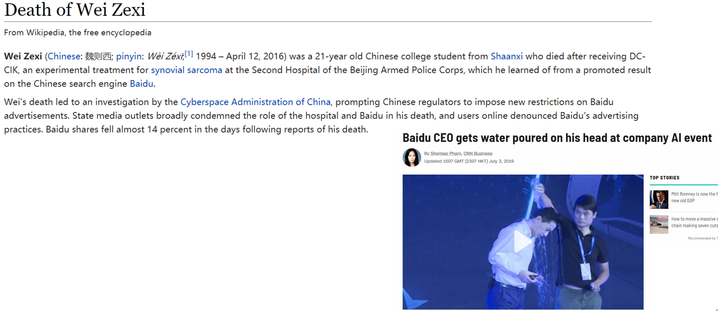
On May 2nd, 2016, stock price of Baidu decreased by 7.92% (￥34.9 billion). Corporate social responsibility matters!
 | Lecture 4: What is a Firm | 22

Agenda
•Organizational Forms of a Firm
–Sole proprietorship
–Partnership
–Limited liability company (LLC)
–Corporation
•Organization Structure of a Corporation
•Agency Problems
 | Lecture 4: What is a Firm | 23





Agency Problem
•Principal: the owner
Investors | •Agent: who is delegated the tasks of management |  | 24
 | •Agency relationship |  | 24
 | – | The relationship exists when a  principal hires an agent to represent his/her interests | 24
Manager | – | For example: stockholders  (principals) hire managers (agents) to run the company | 24
 | – |  | 24
 | •Agency Problem: the principal and the agent might have different  objectives! |  | 24
Firm |  |  | 24
 | Lecture 4: What is a Firm |  | 24



What does the CEO want?
•Supposedly: maximize shareholders’ value |  |  | Objective is: | 25
•Reality: maximize his/her own value |  |  | Aligned | 25
– | Manage the firm well and get rewarded |  | Aligned | 25
– | Make the firm bigger (empire building) |  | Conflicting | 25
• | Larger firms typically pay more to CEOs. |  | Conflicting | 25
– | Build personal reputation |  | Conflicting | 25
• | Make firms bigger and be known for being able to manage large firms. |  | Conflicting | 25
• | Pursue charity so that he/she can be known as philanthropist (慈善家). |  | Conflicting | 25
– | Personal enjoyment |  | Conflicting | 25
• | Buy private airplane, golf club memberships. |  | Conflicting | 25
– | Embezzlement (挪用公款) |  | Conflicting | 25
• | Give contracts to a firm owned by the CEO’s family. |  | Conflicting | 25
 |  | Lecture 4: What is a Firm | Conflicting | 25

Agency Problems are Prevalent at All Levels! (not just CEOs) •Consider a simple scenario: our firm can produce a good with cost=$100, a
customer C is willing to pay $200 for the good.
–  –  –  – | Kickback/bribery: The customer can offer our sales representative a rebate. That is, if she charges $1 less, she gets $0.5 directly from C.  Embezzlement: Our CEO sets up a new firm that purchases the good for $101 from our firm and sells to C for $200.  Information Leakage: Our worker tells C that our production cost is only $100, so C is only willing to pay $105 now.  Destructive competition: Our sales representative for a different region may want to steal the deal by offering a lower price.
“In a firm, one third of people do work, one third do nothing, and one third prevents the first third from doing anything.”
 | Lecture 4: What is a Firm | 26

Real Example — Enron’s Fall
•Fortune: #22 on the “100 Best Companies to Work For in America”, 2000.
•But all the shining numbers were fake, and it went bankrupt in 2001. Investors lost all their money.
•On the other hand, the management team pocketed $681M right before its collapse .
– | The stated (actually nonexistent) profit was only $979M for 2000.
  2000
Title |  | Name |  | 1998 | Total Compensation 1999
Chairman |  | Kenneth L. Lay |  | $22,110,142 | $49,812,093 | $141,657,120
CEO |  | Jeffrey K. Skilling |  | $7,855,243 | $50,377,980 | $72,602,725
Wholesale CEO |  | Mark A. Frevert |  | $4,851,516 | $9,199,342 | $35,803,880
Broadband CEO |  | Kenneth D. Rice |  | $4,320,694 | $1,585,951 | $22,447,662
Transportation CEOStanley C. Horton |  |  |  | $2,221,877 | $7,319,515 | $23,648,826
 |  |  |  |  |  |  | 27
 |  |  | Lecture 4: What is a Firm |  |  |  | 27

Ways to Alleviate the Agency Problem •Managerial compensation
–  – | Incentives can be used to align management and stockholder interests Commonly used incentives include bonus, stocks, and options
•Monitoring (watch over the managers)
–  –  –  – | Internal: limit the power of each person with rules and regulations Board: can replace the CEO  Shareholders: sell shares, use media, sue, vote  Lenders (banks, etc.): debt covenants, refuse to renew loan
•Outside control
– | Threat of takeover |  | 28
– | Labor supply (workers refuse to work for a firm with bad reputation) |  | 28
 |  | Lecture 4: What is a Firm | 28

Summary
•Organizational forms
 |  | Limited Liability | Tax | Management | Transfer  Ownership | Raising Capitals
  Initial
  Capital (RMB)
 | 0 | No | Individual | Full control | N/A | Difficult
  Sole
  Proprietorship
 | 0 | No | Individual | Shared | Difficult | Difficult
  Partnership
 | 0 | Mixed | Individual | Shared | Difficult | Easier
  LP
 | 500,000 | Yes | Corporate | Shared | Difficult | Easier
  LLC
 | Private:10M Public: 50M | Yes | Corporate | Separation | Easy | Easiest
  Corporation
•Financial decisions of a firm
–Goal: maximize firm value
•Agency Problem
– | Conflicting objectives of the CEO and the shareholders |  | 29
 |  | Lecture 4: What is a Firm | 29

Next Time—Raising Capital
•Debt and Equity
•Equity Financing
–Venture Capital
–Initial Public Offering
–IPO Underpricing
–Seasoned Equity Offering
•Debt Financing
– | Different types of debt | Lecture 4: What is a Firm | 30
– | Credit Ratings | Lecture 4: What is a Firm | 30

